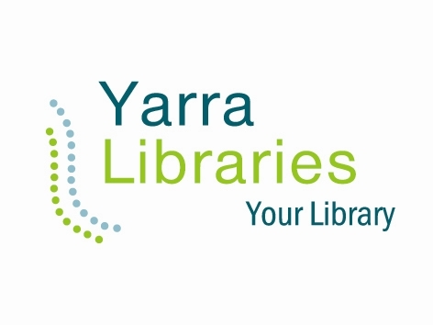
Yarra Libraries invites you to
One Sleep from
the Street
Homelessness in our Community

Join us for a discussion about the issue of homelessness in the City of Yarra.
Guest speakers will give a picture of homelessness today. Come along to find out what role you might play and how you can help anyone you know who is homeless.
Featuring representatives from St Mark’s Community Centre, HomeGround Services and the Council to Homeless Person’s Peer Education and Support Program. Hosted by writer and broadcaster Tony Wilson.

Tuesday 22 October
7.00pm – 8.00pm
The Reading Room, Fitzroy Town Hall
201 Napier Street, Fitzroy
For bookings telephone 1300 695 427 or
email yarralibraries@yarracity.vic.gov.au

Sponsored by The Thomas, Samuel & George Ewing Trust. This is a free event;
bookings essential.

